Proposal

<HF-Happy Fitting>

<Yi Rong, Zipei Chen, Zhenyang Guo>

Advisor: < Vanessa Aguiar>

Submitted in partial fulfillment

Of the requirements of CSC-431

Software Engineering course project

<02.11.2021>

# Preface

This is a proposal for the < HF-Happy Fitting> project for partial fulfillment of the requirements of a Software Engineering course (CSC431) project in the Department of Computer Science at the University of Miami.

This proposal provides the scope and context of the project to be undertaken. It details the intended user group and the value that the system will have to them.

The intended audience of this document is the course professor and teaching assistants so that they can determine whether the project should be approved as proposed, approved with modifications, or not approved.

# Table of Contents

# Overview

## Purpose, Scope, and Objectives

## Project description

* 1. Purpose, Scope, and Objectives

We fond nowadays many people have a problem with their body weight or aim to have a more healthy lifestyle, so the fitting software becomes more and more popular these days. However, our group found most software in the market does not have the function of searching the calories of the foods, so we want to make a software that provides the information about the foods. Another purpose is to inspire people to get a habit of doing sports. Our software will recommend to users different kinds of sports courses when the user is using our software.

Our potential users are those who do not have sports software yet, so our software is completely free at first. We found most people with an ios system already have sports software and the cost we need to consider, our software will be only on Android at present. Also in order to attract more users, we will have a community function in our software.

Our final goal is to have plenty of android users, then we can add some ads to it for making money. When we have more money, we can transplant it to ios and then add the function such as shopping and pro version for further profit.

* 1. Project description

We think our main function should be the most attractive part of the software. So, when the user logs in to the software, there will be a calories calculator, a course list, a forum, and a user page in the software. The calories calculator will at the middle of the screen since it’s our main function. And the course list is the function that recommends users different sports activities and after users finish their sports, the calculator will tell the user the calories they have spent. The forum is for the community function, users can create a new topic and leave a comment on other’s topics. The user page is for a personal profile, the time they spend on sport each day and the calories lost.

A successful software also needs the ability to keep update with user’s needs and fixing the bug. Our software should able to report the bug whenever the bug has happened, and we should able to get users’ feedback through questionnaires or the community’s voice.

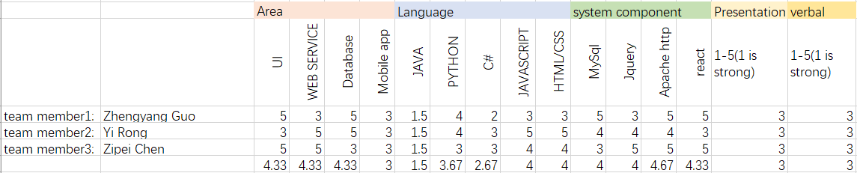

The ability graph for the team members